Brain Invaders Game Design Document

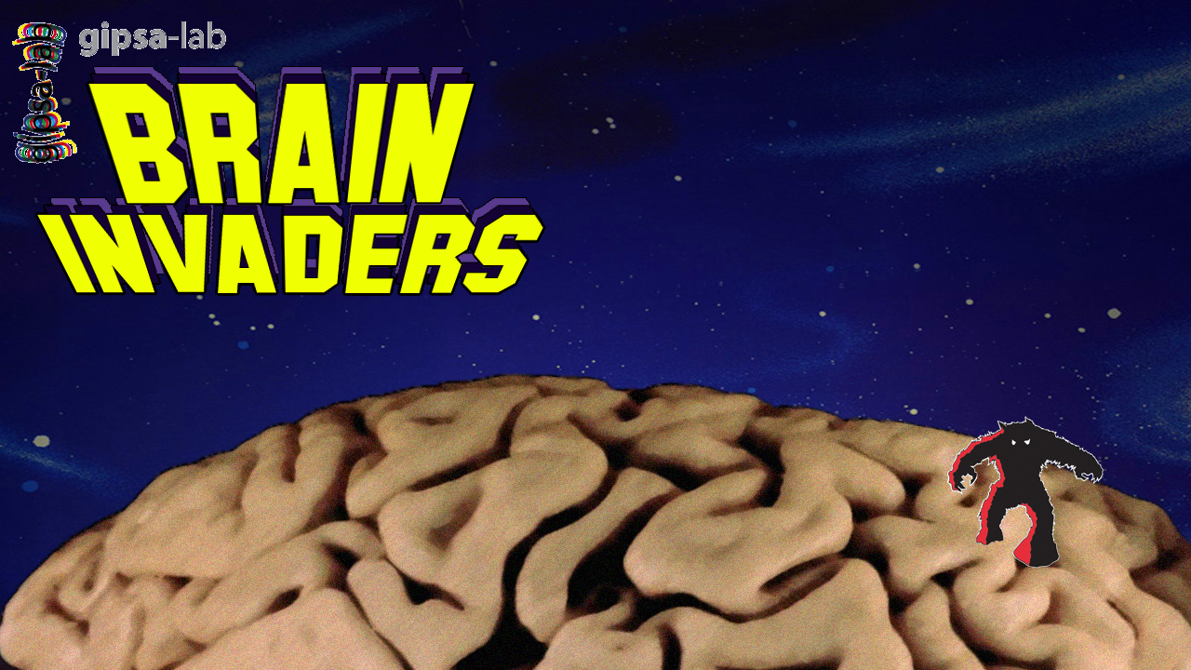

# Table of Contents

Table of Contents 2

Introduction 3

Gameplay Design 4

General Game Flow 4

Game Modes 4

Training Mode 4

Classic Mode 4

Assassination Mode 4

Game Elements 6

Earth floor 6

Aliens 6

Assassination Target 6

Mystery Ship 6

Distractions 7

GUI 7

Leader Board 7

Structure of the Software 8

# Introduction

This document specifies the design of the game “Brain Invaders”, a game like the famous Space Invaders game only controlled by use of a Brain Computer Interface (BCI) using a P300 paradigm. This document specifies the functionality of the game as well as controls, art design and code structure.

# Gameplay Design

In this section we will discuss the gameplay design of the Brain Invaders game. The section will describe the structure of a general gameplay session, as well as distinct gameplay features from the different game modes.

## General Game Flow

In the game the player controls a stationary (unlike the real space invaders) turret trying to take out many invading aliens. The aliens slowly move closer towards the player, speeding up as the game progresses. The player can shoot individual aliens by focusing on them for a small period of time. If the player fails to take out the aliens before they reach the bottom of the level, the game is lost. [ToDO: Look at aliens firing possibility.] To rate the player’s performance, points are awarded whenever aliens are killed.

## Game Modes

Brain Invaders will feature the following modes:

* Training Mode: A Mode to serve as a training to both the player and the BCI
* Classic Mode: Kill all the Invaders before they reach the bottom
* Assassination Mode: A Goal Based level approach on the game.

## Training Mode

The training mode serves as a sort of tutorial to the player, who is trained to take out a single specific alien for a couple of times. In the training mode, the aliens remain stationary and are restored to their full strength a few seconds after a shot has been fired. [This mode serves not only to traing the aiming abilities of the player, but also helps the BCI to calibrate more precisely to the specific player.]

## Classic Mode

The classic mode is the most similar to the original Space Invaders game. In this mode, the player faces an army of aliens placed in a grid, slowly moving to the bottom of the screen by moving from side to side, then moving a step down and repeating this pattern. The aliens speed up over time making it more difficult to hit them. If all the aliens are taken down, a new army spawns at the top of the screen, increasing their speed faster than the previous wave. The goal of the classic mode is for the player to survive for as long as possible. For every alien shot, the player is awarded point. The amount of points varies based on the type of aliens shot, where the aliens placed more in the middle (unlike at the top in the original game, as these are more likely harder to hit) will be worth more points. Occasionally, a mystery ship will fly past the top, which if shot will be worth a random amount of points. The game ends when the player dies, after which the score is added to the high score leaderboards.

## Assassination Mode

The assassination mode is a twist on the Space Invaders concept aimed at gameplay with the P300 paradigm. Whereas the goal of the classic mode is to take out all aliens, the assassination mode determines a set of specific aliens to take out before the invasion reaches the bottom. Though other aliens can be taken out, a positive score is only given for taking out the right aliens, whereas shooting the wrong alien results in a negative score. After all the targeted aliens are shot down, the final score gets calculated, also taking the time spend shooting into account. Afterwards a new level with assassination targets is loaded.

The levels get progressively more difficult by changing the behavior of the aliens (ie, moving in different directions), forcing the player to either be quick or take out some non-targeted aliens and by including distractions that result in the player missing his target. These distractions will be based on research of the P300-paradigm.

# Game Elements

In this section we will discuss the separate elements that the game will contain and describe their behavior within the game.

## Earth floor

Since the game over is heavily dependent on the aliens reaching the bottom of the screen, this element is placed there to indicate whether the aliens have landed.

## Aliens

The game will contain multiple aliens, that have a different score value (10-30 in Classic mode, -20 in Assassination Mode). When focused upon, the aliens will be shot by the player. The aliens move in a specified path and cause a game over if they manage to reach the Earth Floor.

  
*Aliens, worth 30, 20 and 10 points respectively (Classic Mode)*

## Assassination Target

Similar to the normal Aliens, only with a red colour (cyan when blinking for the P300) indicating that they should be a target. The player earns 200 points for each assassination target taken down. They behave the same as other aliens, though teleportation might occur in later levels.

  
*Assassination Target*

## Mystery Ship

A ship that appears randomly in both Classic and Assassination mode. Swiftly moves through the screen and gives a score of 50, 100, 150 or 300 points when shot by the player. Does not cause failure when missed, not is it a vital assassination target despite its red colour (might want to change that to prevent confusion).

  
*Mothership*

## Distractions

Pending.

## GUI

The Graphical User Interface communicates information about the game to the player. At the top a scoreboard will be included to show the points the player has earned. A life indicator can be included as well, depending on whether we decide to have more than one player life per session.

## Leader Board

After the game is finished, the player score, along with a requested name, can be uploaded to the game’s leader boards. There will be a leader board for the classical mode as well as each individual level in the assassination mode.

# Structure of the Software

This section gives an overview of the structure of the Brain Invaders software.